Deep Learning based Paddy Leaf Disease
Identification

Meena G,A N RamyaShree,Anusha L,Jyoti P,Priya E
Department of CSE,RNS Institute of Technology Bangalore,India ,
meenagkannan1998@gmail.com,ramyashree.a.n@rnsit.ac.in,1rn19cs400.anusha@gmail.com,India jyotip0108@gmail.com ,India priyaedavalapathi@gmail.com

Abstract—Paddy is one of the most important agricultural commodities in the world with a number of cuisines scattered across the globe, which are incomplete without it. In developing countries like India, paddy has spurred agriculture driven growth in the past century, when export of agricultural produce was the major source of foreign exchange. At times, the prices face a blow from the demand side, while at times facing drastic conditions on the supply side. In such years, farmers often cannot afford the services of agricultural consultants for tasks such as detection of leaf diseases and addressing them at the earliest. The solution we have proposed, is a low cost system that uses CNN Algorithm to detect leaf diseases in the leaves of paddy plants with an average
93.27% accuracy to make things easier for both the farmers as well as consumers, since this would balance the prices at a median price, which is both profit-earning for farmers as well as affordable to the consumers at all times of the year.
Index Terms—Deep Learning, Convolution Neural Network
(CNN),Perceptron.

I. INTRODUCTION

The condition of a paddy leaf is an important aspect that affects the yield of paddy, both in terms of quantity as well as quality. Paddy leaf disease detection is an image processing based system that uses visual clues on the leaf surface to know the disease. Earlier, complex computer programs to identify such diseases were never materialized or brought into the mainstream owing to the affordability of agricultural consul- tants and advisors. However, as the platforms have become more user-friendly than ever, why shouldn’t this decision be revisited? When a computer is taught to simply recognize leaf diseases to begin with- suggesting remedial measures for the same can be easily incorporated. Since diseases affect the appearance of a leaf, which can be perceived by vision, using image processing is a good approach.Unlike in other applications where a conflict of understanding may hinder project development- the presence of a particular undesirable trait or color on a ‘Paddy leaf’ has a universal bearing across the world[1].
A. Convolution Neural Network
In deep learning, a convolutional neural network (CNN, or ConvNet) is a class of deep neural network most commonly applied to analyzing visual imagery. They have applications in diverse areas. These are regular versions of multi-layer perceptrons which are fully connected networks means each neuron in a layer is connected to all other neurons in the next layer. It makes these networks prone to overfitting data. CNN use hierarchical pattern which includes simple & complex patterns in the data.

B. CNN Architecture
A CNN design is shaped by a heap of particular layers that change the info volume into a result volume (for example holding the class scores) through a differentiable capacity. A couple of particular sorts of layers are ordinarily utilized. CNN architecture is roused by the association and usefulness of the visual cortex and intended to mirror the network example of neurons inside the human mind. The neurons inside a CNN are parted into a layered structure such that each arrangement of neurons breaking down a element of the picture.Different CNN layers with description are listed below and Fig.1 describes basic CNN layered Architecture.
Convolutional layer:This layer is the first step in CNN,
here 3*3 part of the given matrix which was obtained from High-pass filter is given as input. That 3*3 matrix is multiplied with the filter matrix for the corresponding position and their sum is written in the particular position. This is shown in the below figure. This output is given to pooling layer where the matrix is further reduced. Convolutional Layer.
Pooling layer: In Pooling layer 3*3 matrix is reduced to
2*2 matrix, this is done by selecting the maximum of the particular 2*2 matrix for the particular position.
Fully connected layer: The output of the pooling layer is flattened and this flattened matrix is fed into the Fully Connected Layer. In the fully connected layer there are many
layers, Input layer, Hidden layer and Output layers are parts of it. Then this output is fed into the classifier, in this case Softmax Activation Function is used to classify the image into healthy or a leaf with a particular disease if present. Fig.1 shows the Fully connected layer and Output Layer. Output layer: It creates the last probabilities to decide a defined class for the picture.

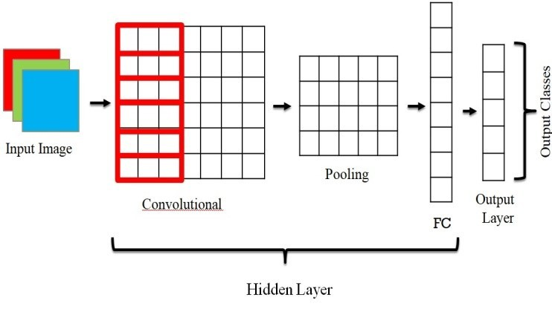

Fig. 1. CNN Layered Architecture

II. LITERATURE REVIEW
Image processing is a wide area of research field, the literature survey has been carried out to study the projects and researches previously performed on this same topic. We have found many image processing approaches implemented on various datasets which has motivated us to do this project. Prajwala T M, et al.proposed a technique called Leaf Disease Detection using Convolutional Neural Contemporary Computing which predicts tomato leaves diseases.This soft- ware has by far been very successful in detecting leaf diseases accurately to a large extent. Moreover, this piece of software has actually been used on field by the farming community around Surathkal,Karnataka,India. It has really helped the farmers a lot. However, tomato growing near Surathkal is not very popular and the software did not manage to reach other places where tomato’s are grown in large quantity.The project was still in its early phases and did not evolve to the full extent. This software used to yield highest accuracy rates, since it was trained by over 54000 images of paddy leaves.One basic thumb rule in machine learning has always been that a higher number of inputs almost always result in better accuracy while classifying.This is another aspect to look into, since a more powerful software, designed perfectly would be similarly accurate with lower number of images in the training dataset. It would be always better to see farmers actually using a software
to address their day to day problems [2].
Akshay Kumar, et al. proposed “Image Based Paddy Leaf Disease Detection” and it was sopnsered by National Institute of Technology, Surathkal, Karnataka 2019 and proposed as an advancement to the discussed technique. The 2018 proposed system used only LeNet, this model uses 4 CNN architecture using LeNet , VGG16, ResNet50 and Xception. This multitude of models were tried on the Plant Leaf dataset. This project yielded better accuracy rates than the previous one which was
proposed at Noida in 2018. The main advantage it had over its predecessor is the implementation of CNN using multiple layers and different algorithm providers. The main difference actually arises out of the use of totally different algorithms which are designed keeping in mind some concept that is basically completely different from the other provider. This acts as a combination of different ideas. Thus, the fact is that these different layers were able to recognize different features or patterns the previous version missed out on. Though this piece of work has set the performance parameters quite high, even this has not found widespread mainstream use among farmers. Until this is true, no piece of software would be considered totally successful[3].
Mokhtar, et al. proposed “Paddy leaves diseases detection approach based on Support Vector Machines”.This research work was among the first to use Support Vector Machines to detect leaf diseases in Paddy plants, based on image processing. Although this system didn’t have accuracy as high as those observed in the systems developed by The National Institute of Technology, Surathkal, it was still a pioneer in deploying Support Vector Machines for this purpose. To be noted the data set used for model development contains around
16000 images which is lesser than number of images used in the NITK Project, which might have resulted in a drop of model accuracy. As quoted earlier, this is one basic aspect to consider in machine learning- the larger the database for training- the more accuracy the trained model yields. However, it was also the first work to record such an accuracy rate- which was pretty good for a system created to experiment with the behavior of SVMs on leaf disease detection[4].

III. DESIGN CONSIDERATION
The following considerations are taken into account prior to the proposed model development.

A. Image captured but no leaf detected
This case describes when the camera/dataset captures image, but it does not have the leaf content which the system requires. For this situation a message is shown to the client expressing the issue, that is, the user will be asked to return the picture until the framework can remember it is a picture containing leaf.

B. Image captured but not clear
This case describes when the camera/dataset captures image, image with leaf is also recognized but it is not clear. In this case the user will be asked to re-enter the leaf image until the system is able to get a good image else the user can go ahead with the same, results might vary.

C. Unable to get an Image into buffer
This case describes when the camera/dataset is unable to get an image into system buffer. In this case the system will report an error because it did not have any data to work with as the image buffer was empty, the system will display the error. The system can handle this as an expectation and proceed with the
code by taking a random buffer values, but again this will lead to mismatch of results.

D. System bugs and errors
When there are bugs in the program. In this case the system will handle this bug and error by a concept called exception handling, and need to write assertions in the code so that the code can report these bugs and errors, so the client can amend this once found.

SYSTEM ARCHITECTURE
A System design is the calculated model that characterizes the construction, conduct, and more perspectives on a frame- work. A design portrayal is a proper depiction and portrayal of a framework, coordinated such that supports thinking about the structures.The leaf image is fed as input to leaf disease detection system, in which it subjected to preprocessing and later its features are extracted [5]. The extricated highlights are used by the softmax classifier.The input image is pre-processed and converted to grey scale image to find the Threshold value based on input image. Based on Threshold value further image sharpening is done, then further process is carried out.The proposed architecture described in Fig.2.

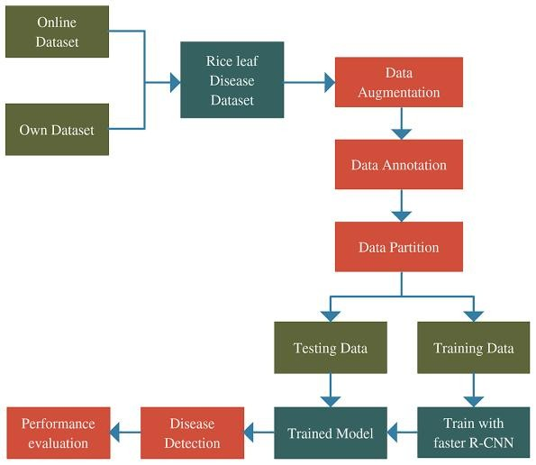

Fig. 2. Proposed System Architecture.

The system which is being used currently performs the task of detecting the type of paddy leaf disease. The input image is fed into system to find out edges and after sharpening the edges, the highlights are extricated and afterwards provided to classifiers which are trained to identify the disease.The different stages are listed below.
1.RGB to grey scale
In the initial step of proposed approach, store a solitary variety pixel of a RGB variety picture we will require 8*3
= 24 pieces (8 digit for each variety component).Only 8 bit is expected to store a solitary pixel of the picture. Grayscale pictures are a lot simpler to work inside an assortment of undertaking like In numerous morphological activity and picture division issue, it is more straightforward to work with single layered picture (Grayscale picture ) than a
three-layered picture (RGB variety picture ) It is likewise simpler to recognize highlights of a picture when we manage a solitary layered picture[6][7].
2.Noise Removal
Clamor expulsion calculation is the method involved with eliminating or decreasing the commotion from the picture. The clamor expulsion calculations diminish or eliminate the perceivability of commotion by smoothing the whole picture leaving regions close to differentiate limits. Commotion evacuation is the subsequent advance in picture pre-handling. Here the grayscale picture which was gotten in the past advance is given as info. Here we are utilizing Median Filter which is a Noise Removal Technique.Here we are using Median Filter for the Noise Removal Technique [8].
3.Thresholding
Thresholding is a kind of picture division, where we change the pixels of a picture to make the picture more straightforward to break down. Most often, we use thresholding as a method for choosing areas of interest of a picture, while overlooking the parts we are not worried with.We utilize Basic Global Thresholding [9].
4.Image Sharpening
Picture sharpening alludes to any upgrade procedure that features edges and fine subtleties in a picture. Expanding yields a more honed picture. Picture honing is finished by adding to the first picture a sign relative to a high-pass separated rendition of the image[10].
5.Feature Extraction and Classification Feature extraction is a curse of dimensionality decrease method by which an underlying arrangement of crude information is diminished to additional sensible gatherings for handling. In the wording of AI, characterization is viewed as a case of managed learning, i.e. realizing where a preparation set of accurately distinguished perceptions is accessible. The corresponding unsupervised procedure is known as clustering, and involves grouping data into categories based on some measure of inherent similarity or distance[11].
6.Noise Removal
Median Filtering approach has been used to remove the noise.In this filtering approach middle channel is a non-direct computerized sifting strategy, frequently used to eliminate commotion from a picture or sign. Here 0’s are appended at the edges and corners to the matrix which is the representation of the grey scale image. Then for every3*3 matrix, arrange elements in ascending order, then find median/middle element of those 9 elements , and write that median value to that particular pixel position [12][13].Algorithm 1 describes proposed CNN based Paddy Leaf disease detection.

IV. RESULT ANALYSIS
The proposed system used around 1074 pictures of healthy and unhealthy paddy leaves which are collected from UCI Library and Kaggle public data set.The leaf varieties are described in Fig.3.The proposed system detects paddy leaf disease with an average accuracy of 93.27%.
Algorithm 1 : CNN based Paddy Leaf disease detection
BEGIN:
1. Build the required libraries.
2. Add on two-dimensional convolution layer using ConvT- woDim() in the neural network.
3. Add on 2-layered max pooling layer utilizing max pooling Two Dim() function in the brain organization.
4. Apply flattening layer using Flattenmet() function.
5. Apply fully connected layer with an activation function of ReLu layer.
6. Add on dense layer using denselayer() with an activation function of Softmax method.
7. Operate image augmentation using Image InfoGenerator()
function.
8. Loads up the pictures from training and test sets and put them in different Variables.
9. Fit the data and train the model on training dataset using fitgeneratormet() function.
10. Test the exactness of sick paddy leaves of the model on the test set.
11. Examine the sickness on an irregular paddy leaves picture and print the result.
END:

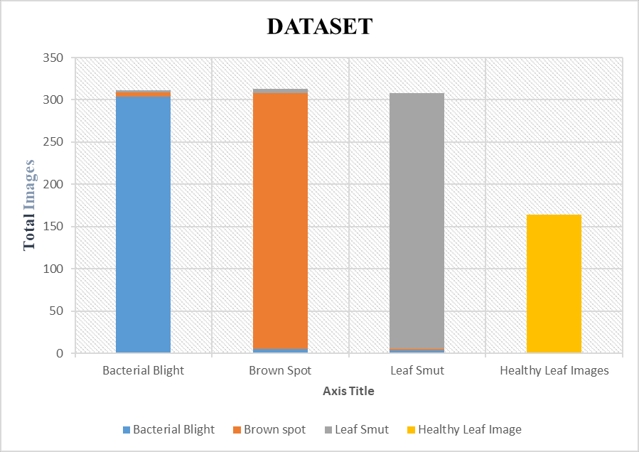

Fig. 3. Dataset Description

A paddy leaf is given as input to the proposed system and it classify it as healthy or not-healthy leaf.If it is not healthy then specific disease categories variations are detected and the same described by the proposed system.Fig.4 & Fig.5 describes bacterial paddy leaf and its analysis.Fig.6 & Fig.7 describes brown spot paddy leaf and its analysis. Fig.8 & Fig.9 describes leaf smut diseased paddy leaf image and its analysis.

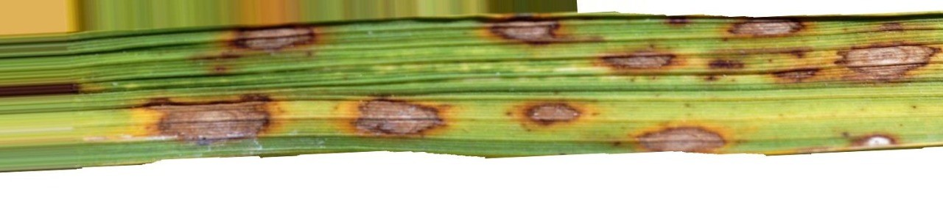

Fig. 4. Bacterial Diseased Paddy Leaf

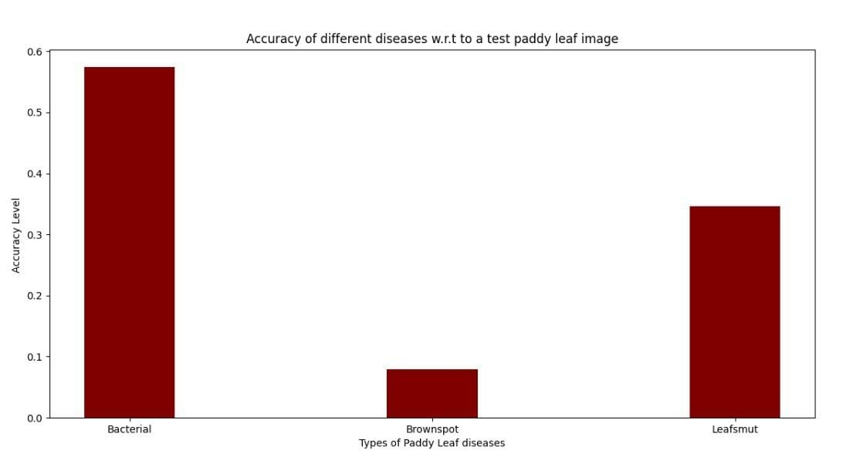

Fig. 5. Bacterial Diseased Paddy Leaf Image Analysis

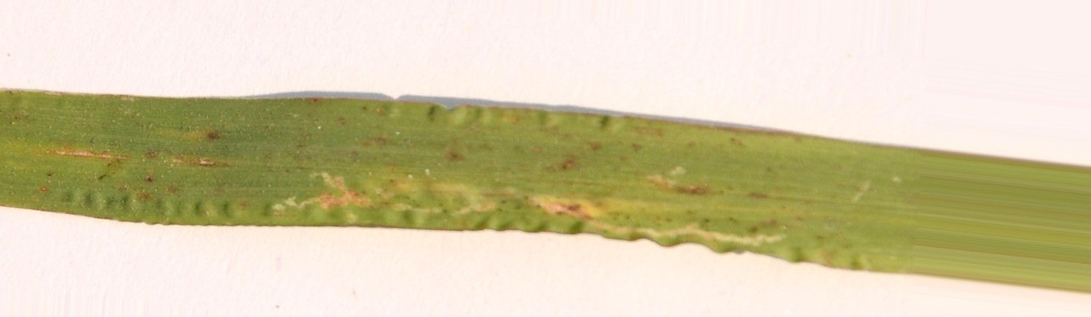

Fig. 6. Leaf smut Diseased Paddy Leaf

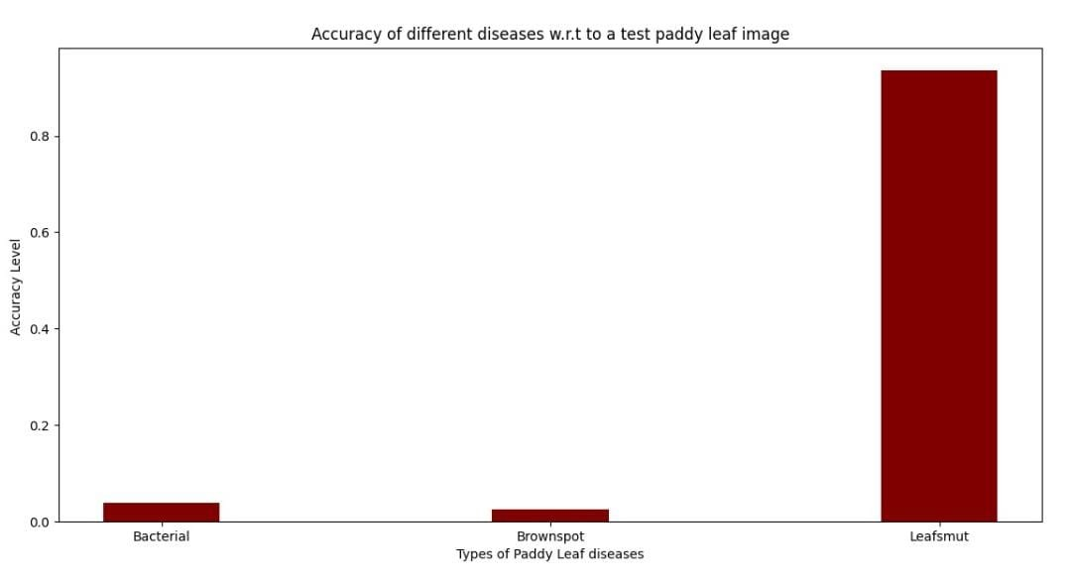

Fig. 7. Leaf smut Image Analysis

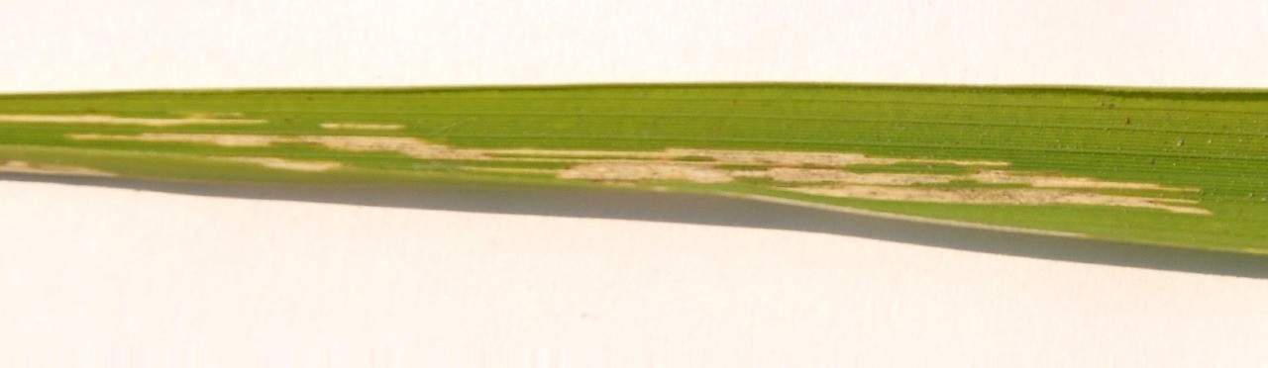

Fig. 8. Brown spot Diseased Paddy Leaf

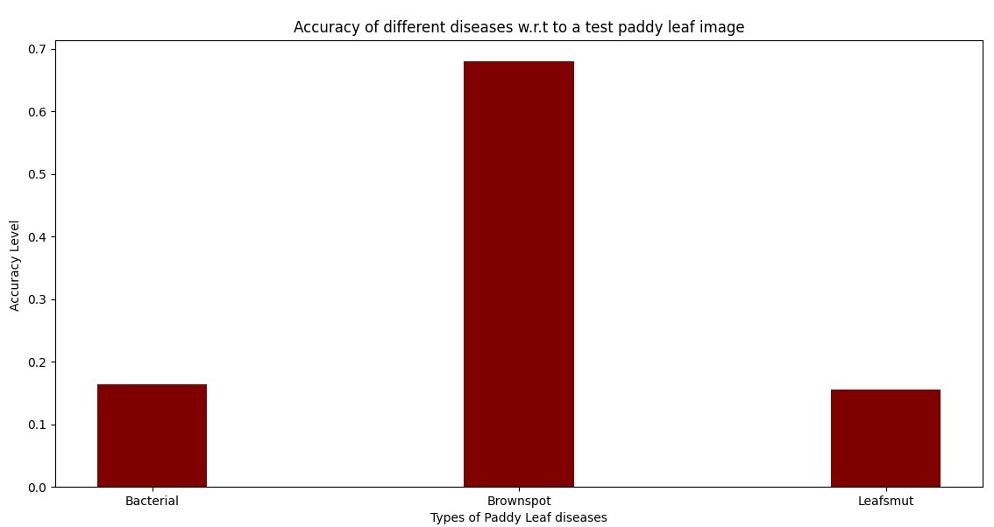

Fig. 9. Brown spot Image Analysis
V. CONCLUSION & FUTURE WORK

A. Conclusion
In the proposed system ,a simple unique method is used to detect paddy leaf diseases using various CNN architectures. It center around various techniques for expectation and grouping of leaf sicknesses. The various strategies are examined for picture handling procedures. We can also alter accessible calculations to get great precision while grouping the disease specific leaves. Precision and early recognition of these sicknesses will assist the farmers such that it avoids the potential risk and forestall tremendous misfortunes. The strategy utilized here will give the name of the sickness as the class to which the picture has a place as the outcome. This task likewise assists the farmers with leaf infection categories with a limited quantity of information.

B. Future work
At the present level, farmers at the lower end of the spectrum may use proposed system to provide pictures of affected leaves as input to the framework and get the name of the disease as the result,which then quoted to a pesticide retailer who can easily be addresses with relevant sprays. The proposed system is also trained for various other paddy leaf disease categories.The large scale deployment of this system by agrarian authorities over large parcels of land helps to detect epidemic- like diseases right in the inceptive stages and address them on the higher level with ease.

REFERENCES

[1] Karunya Rathan, Abirami Devraj, K.Indira, Sarvepalli Jaahnavi “Iden- tification of plant disease using image processing technique”, pp.4-6
April,2019.
[2] Prajwala, T. M., Alla Pranathi, Kandiraju Sai Ashritha, Nagaratna B. Chittaragi and Shashidhar G. Koolagudi. “Tomato Leaf Disease Detection Using Convolutional Neural Networks.” 11th International Conference on Contemporary Computing (IC3),pp.1-5,2018.
[3] Voleti Nagaveni and B. K. Raghavendra. “A Review on Machine Learning Classification Techniques for Plant Disease Detection.” 5th International Conference on Advanced Computing Communication Systems (ICACCS),pp:281-284,2019.
[4] Yao, Qing, Zexin Guan, Yingfeng Zhou, Jian Tang, Yang Hu and Bao-jun Yang. “Application of Support Vector Machine for Detecting Rice Diseases Using Shape and Color Texture Features.” International Conference on Engineering Computation,pp:79-83,2019.
[5] V. Vanitha “Rice disease detection using deep learning”, International Journal of Recent Technology and Engineering (IJRTE) ,Vol 7,Issue- 5, Feb2019.
[6] Hasan, Md. Jahid, Shamim Mahbub, Md. Shahin Alom and Md. Abu Nasim. “Rice Disease Identification and Classification by Integrating Support Vector Machine With Deep Convolutional Neural Network.”
1st International Conference on Advances in Science, Engineering and
Robotics Technology (ICASERT) pp:1-6,2019.
[7] Maniyath, Shima Ramesh, Vinod P V, Niveditha M, Pooja R., Prasad N, Shashank N and R Hebbar. “Plant Disease Detection Using Machine Learning.”International Conference on Design Innovations for 3Cs Com- pute Communicate Control (ICDI3C) pp:41-45,2018.
[8] N. Shah and S. Jain, ”Detection of Disease in Cotton Leaf using Artificial Neural Network,” Amity International Conference on Artificial Intelligence (AICAI), 2019, pp: 473-476,2019.
[9] Chokey, Tenzin and Sarika Jain. “Quality Assessment of Crops using Machine Learning Techniques.” 2019 Amity International Conference on Artificial Intelligence (AICAI) pp: 259-263,2019.

[10] S, Santhosh Kumar and B. K. Raghavendra. “Diseases Detection of Var- ious Plant Leaf Using Image Processing Techniques: A Review.” 2019
5th International Conference on Advanced Computing Communication
Systems (ICACCS) ,pp:313-316,2019.
[11] Islam, Taohidul, Manish Sah, Sudipto Baral and Rudra RoyChoudhury. “A Faster Technique on Rice Disease Detectionusing Image Processing of Affected Area in Agro-Field.” 2018 Second International Confer- ence on Inventive Communication and Computational Technologies (ICICCT),pp:62-66,2018.
[12] Narmadha, Rajasekaran and G. Arulvadivu. “Detection and measure- ment of paddy leaf disease symptoms using image processing.” 2017
International Conference on Computer Communication and Informatics
(ICCCI),pp: 1-4,2017.
[13] Ramesh S, Rice Blast Disease Detection and Classification Us- ing Machine Learning Algorithm. 2nd International Conference on Micro-Electronics and Telecommunication Engineering (ICMETE) pp:255–259,2018

